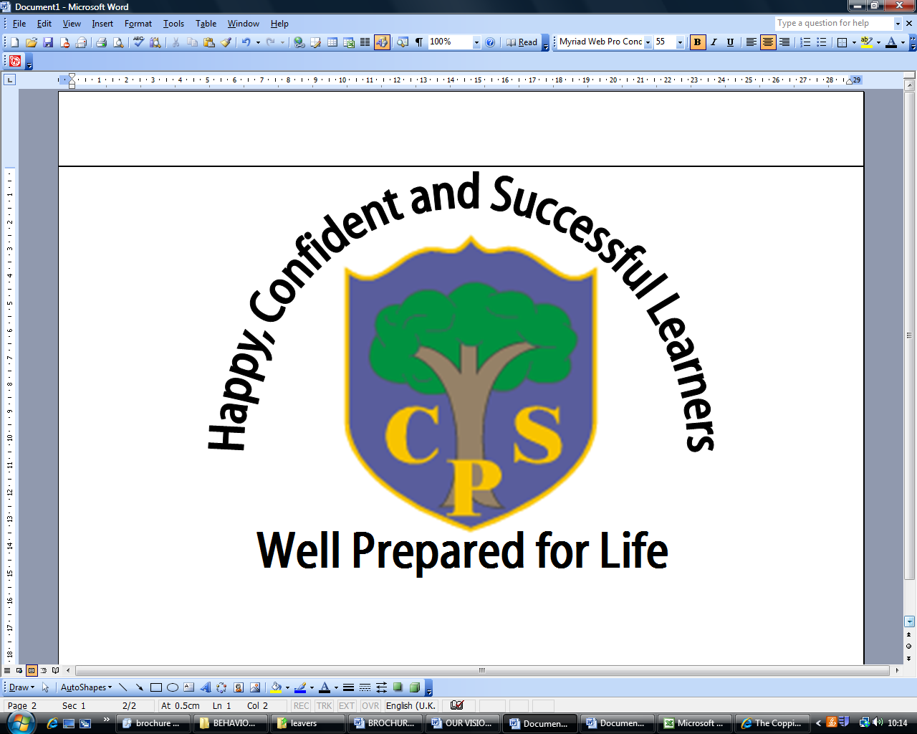
AUTUMN 1 YEAR 5
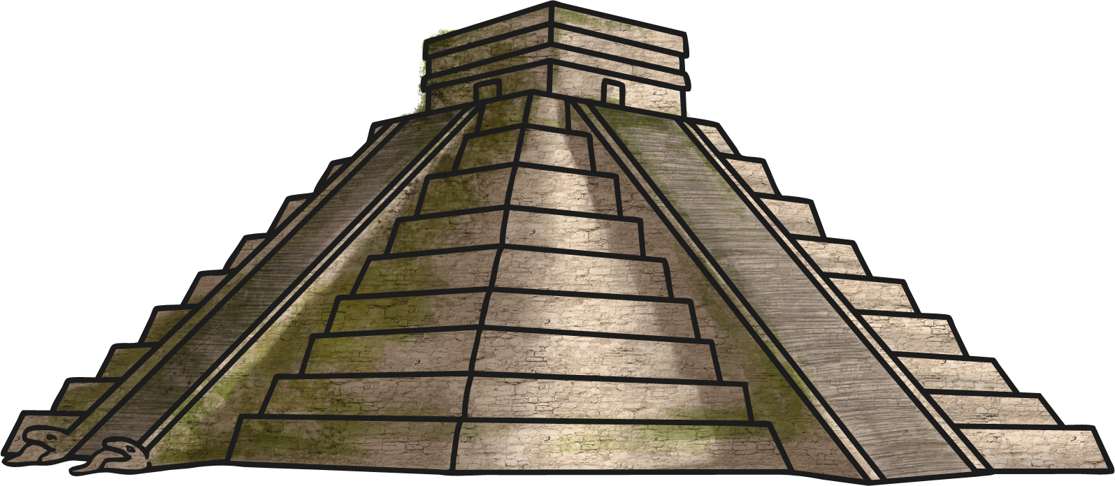
The Mayan Civilisation

English | *This half term the children will be writing a suspense story with a flashback. They will develop their ability to be descriptive and their knowledge of speech punctuation. They will also consolidate their use of ISPACE sentence openers.  * In reading, the children are focussing on Michael Morpurgo’s, ‘I Believe in Unicorns’. They will develop their understanding of inference and spend time discussing and extending their opinions of the text.
Maths | The sole focus of this half term is to consolidate and extend children’s understanding of the number system, beginning with place value. The children will consolidate the different calculations used for addition, subtraction, multiplication and division. The children will be expected to use the column method for long multiplication.
Science | Not covered this half term.
Computing | This half term we will be start by looking at internet safety and the importance of being safe on the internet. The children will practise their research and safe searching skills in topic lessons.
History | In the topic the children will be learning about the Ancient Maya. Through this topic, the children will gain understanding of the Maya people; their customs, religions and significant events.  The key objectives are:  Knowledge & understanding  - To sequence key events of period studied.  - To know some of the main events, people and changes throughout history.  - To know and describe characteristic features of past societies and periods of time using appropriate language.  - To know vocabulary such as era, period, century, decade, BC, AD, after, before, during.  Historical Skills  - To use pictures, artefacts and writing to help me draw conclusions and form my own opinion.  - To identify some changes within & across different periods.  - To describe the passing of time using key vocabulary to convey my understanding of the past.  - To record and communicate knowledge in different forms
Geography | During our topic on the Ancient Maya, children will also use their geographical skills to locate countries, cities and significant landmarks on maps. They will:  - use maps, atlases, globes and digital/computer mapping to locate countries and describe features studied  - understand geographical similarities and differences through the study of human and physical geography of a region of the United Kingdom and a region of central America.
Physical Education | Games: The children will be learning skills and rules for playing dodgeball as well as experiencing other invasion games.  Gymnastics: The children will be learning about using their bodies to make ‘bridges’. They will do this individually, collaboratively and using different apparatus.
Art and  Design | This half term the children will design and create a Maya mask based on research and will produce art based on the Maya alphabet.
Design and  Technology | Not covered this half term.
Music | This half term will focus on rock music. They will discuss and appraise various songs such as Jon Bon Jovi’s, ‘Living on a Prayer’ and will use glockenspiels and percussion instruments to improvise music to accompany them as they sing.
Religious Education | The children will be learning about the bible and the different parts of the bible. They will then begin to look at what a pilgrimage is, in preparation for their trip to the Cathedral.
PSHE | Weekly whole school assembly themes (see assembly themes) and relevant whole class THRIVE activities.  The children will be learning about how their actions can impact on others and will be challenged to work on being more helpful at home.
Spanish  (KS2 only) | The children will revise the Spanish taught last year and will work on their ability to discuss the features of a high street. They will learn how to ask if there is a particular shop nearby as well as responding appropriately to the question.

