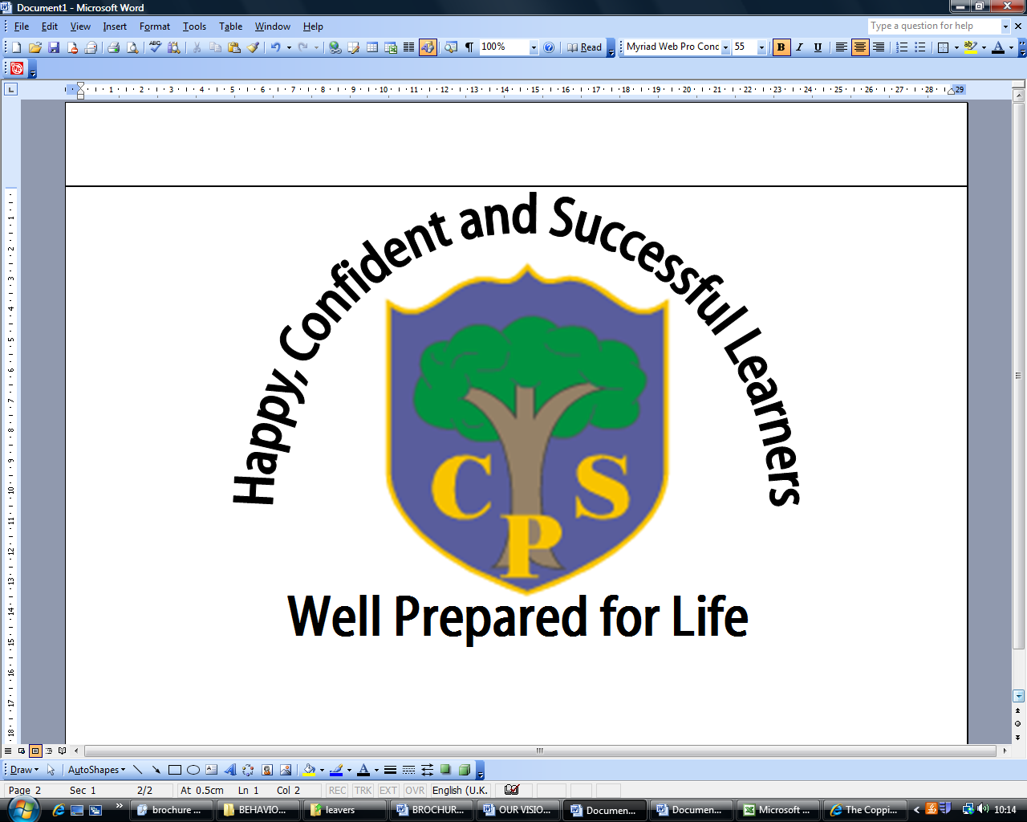
Autumn 1 YEAR 4

Horrible Histories
English | In English we will be working on overcoming a monster story, developing their descriptive language and creating suspense. The key text we will focus on is ‘Beowulf’.  We will be developing our understanding of sentence structure and using this to improve our writing. The children will use the model of Beowulf to create their own overcoming a monster story.
Maths | We will be focusing on number this half term and the four main processes in maths; addition, subtraction, multiplication and division.  We will develop written and mental strategies when solving problems using the four operations.
Science | During this half term we will focus on teeth and healthy eating. We will identify the different types of teeth that we have and discuss why we have milk teeth that are replaced with adult teeth. We get to experiment using disclosing tablets to investigate just how clean our teeth are and we look at the teeth of other animals and how they are adapted to suit their diet.
Computing | We will be focussing on Internet Safety. Using Zu3D and digital cameras, we have the opportunity to create our own stop animation videos using props and a background of our choice. We get to find out how to make this video effectively and get to share our work with the rest of the year when we are done.
History | Our topic for this half term is called, ‘Horrible Histories’ and we learn all about The Anglo-Saxons.  The key objectives are:  *To place events, people and changes into correct periods of  time on a timeline.  *To understand the reasons for the Anglo-Saxon invasions of Britain.  *To develop an understanding of Anglo-Saxon settlements and kingdoms: place names and village life.  *To understand the importance of Anglo-Saxon artefacts.
Geography | As part of our topic, we look at the countries that the Anglo-Saxons originated from and research their movement over to Britain.
Physical Education | For this half term we focus on basketball and dance. The children will be learning the Men in Black dance which involves dancing in unison, staying in a formation and choreographing their own routine. During basketball, the children will learn the different skills required and eventually play games against each other.
Art and  Design | This half term we get to look at images of Anglo-Saxon patterns, artefacts and get to design our own.
Design and  Technology | This is not covered this half term
Music | During this half term we listen to different types of music and discuss pitch, and introduce notation.
Religious Education | In this half term we learn all about Hinduism. We will find out about the different deities such as Ganesh and Krishna and learn about the festival of Diwali.
PSHE | Weekly whole school assembly themes (see assembly themes) and relevant whole class THRIVE activities.  The Worry Eater is introduced in this half term and we discuss our worries and how to make ourselves feel better by sharing them with our class Worry Eater.
Spanish  (KS2 only) | The children will continue to learn vocabulary for body parts, colours and adjectives.

