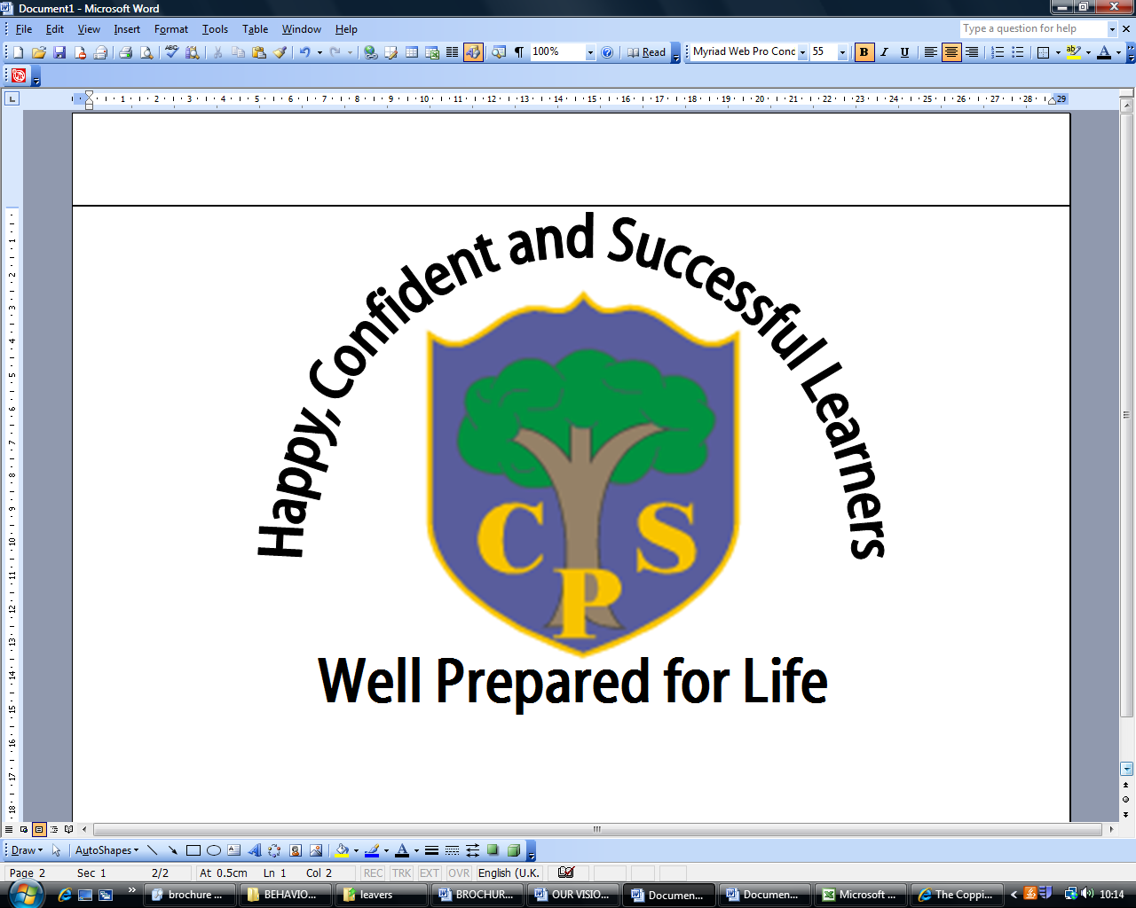
AUTUMN 1 YEAR 3
Digging Deep
English | Children will be focusing on recounts this half term, looking at the story of ‘Jack and the Beanstalk’ and writing a fairy-tale from a different character’s point of view. There will be a focus on the use of descriptive language, the structures of different sentences, using a variety of conjunctions and different sentence openers throughout their writing.
Maths | This half term children will be looking at number, particularly focusing on the value of hundreds, tens and ones, ordering and comparing numbers, writing numbers in words and partitioning numbers. We then move on to calculation strategies for addition, subtraction, multiplication and division. They will also be applying this knowledge to solve worded problems.
Science | As part of our Digging Deep topic the children will explore the different rocks and soils that make up our Earth. We will collect and evaluate different samples of the soils in our school grounds. We will also look at the different properties of rocks and identify and sort the three different types of rock; sedimentary, igneous and metamorphic.
Computing | Children will be learning about keeping safe on the internet, ensuring they have a sound understanding of how to stay safe and use the Internet appropriately. We also look at basic coding, algorithms and debugging.
History | Not covered this half term.
Geography | As part of our Digging Deep topic, we look at how volcanoes are formed, how they erupt, what impact they have on their local environment and the humans living near them.
Physical Education | The children from one of the year group classes will go swimming every week and will develop their swimming skills. During PE lessons, we cover gymnastics skills based around stretching, balancing and movement. Outdoor PE lessons consist of team games starting with tag rugby.
Art and  Design | Linked to our R4L book, The Iron Man by Ted Hughes, the children will create collages of the Iron Man’s face using a variety of different materials.
Design and  Technology | As part of our Digging Deep topic, the children will be making and exploding their own volcanoes. They will use recyclable materials to create the base and structure of the volcano.
Music | The children will look at the different examples of rhythm and blues music, concentrating on tempo, pitch and dynamics. They will also learn to sing a song called ‘Let My Spirit Fly’.
Religious Education | Children will be looking at the Bible and exploring why the Bible is important in the Christian faith.
PSHE | We will focus on whole school PSHE themes: caring, cooperation and helpfulness. Children will also take part in circle times to discuss arising issues. They will also be developing their confidence to speak aloud during class discussions.
Spanish | The children will learn their numbers to 10. They will be taught to hold a simple conversation including their name and age.

