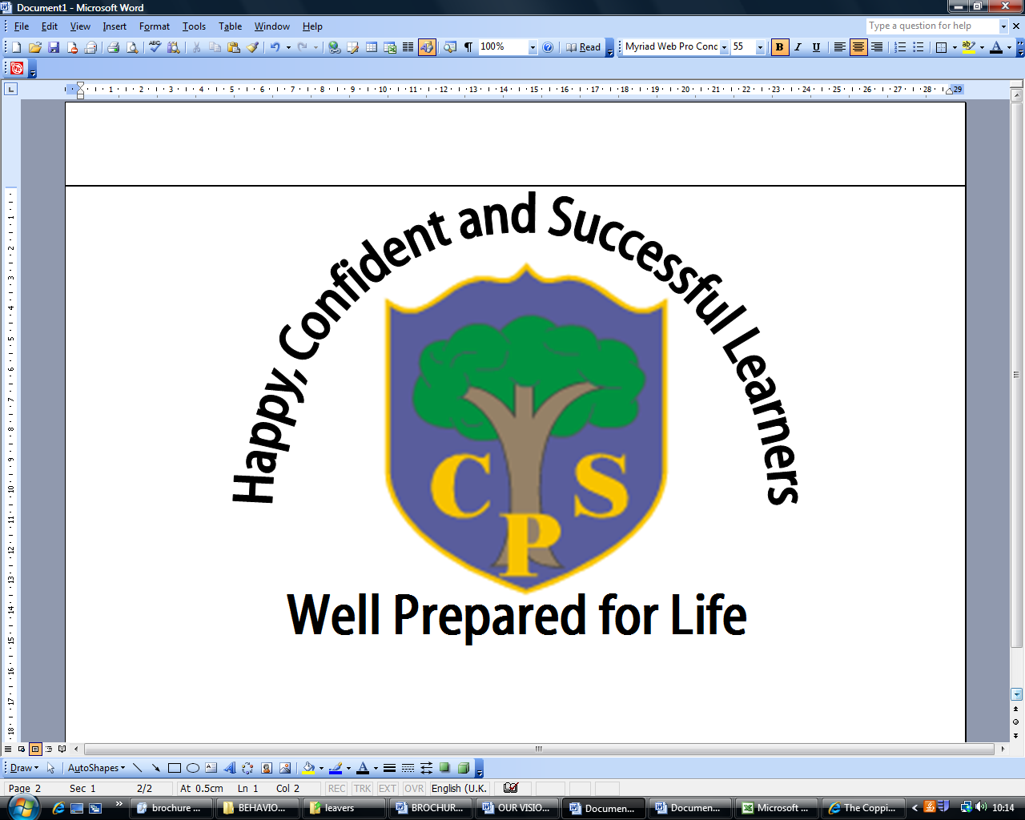
Autumn 1 Year 2

Happy Families/The Victorians

English | *The children who continue to require support with phonics will follow the RWI phonics programme, focusing on securing their knowledge of sounds and applying them to their reading and writing.  *Children off the programme will progress to RWI spellings.  All children will work on developing their basic sentence structure and use of punctuation and use this to write familiar stories.
Maths | *The children will be working on securing the recognition of numbers to 100 and securing their understanding of place value, knowing what each number represents, addition and subtraction.  *Fortnightly skills tests will be undertaken, addressing a range of mathematical skills, covering number, data and shape.
Science | Not covered this half term.
Computing | The children will be learning about Internet Safety, ensuring they know about the dangers they could face on the internet and how to be a safe user. They will begin a topic on coding which will continue into Autumn 2.
History | The children will be exploring how life has changed since the Victorian era with a focus on :  *ordering events chronologically  *gaining an understanding of why people in the past did things and why they became famous  *finding information from a variety of sources  *asking and answering questions about the past  *past and present inventions
Geography | Not covered this half term.
Physical Education | Fitness: Focusing on a range of exercises to improve health and fitness.  Gymnastics: Points and Patches. This involves balancing on small and large body parts and incorporating this into a gymnastic sequence.
Art and  Design | The children will use a range of materials (pencil, chalk, pastels) to create a range of pictures linked to our Happy Families/Victorian topics. The children will complete a tile in the design of William Morris.
Design and  Technology | The children will design, measure and create a picture frame for their family portrait.
Music | The children will be learning about the tempo, pitch, rhythm and beat of a range of musical pieces. They will also follow the Charanga scheme singing a variety of songs.
Religious Education | The children will learn about the parables Jesus told and the messages that are conveyed.
PSHE | Weekly whole school assembly themes (see assembly themes) and relevant whole class THRIVE activities.  We will also be discussing family life, how families are different and what makes us feel safe and happy.

