

Come and discover our wonderful nursery environment and take a tour around our school.

**The Coppice Nursery**

**Invites you to our**

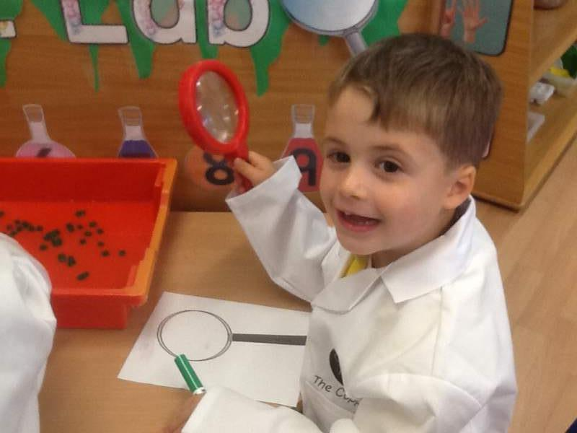

**OPEN EVENING**

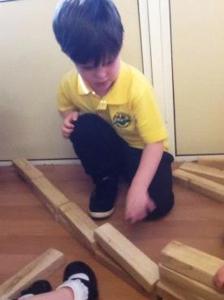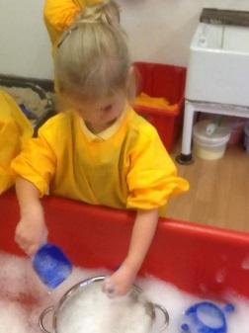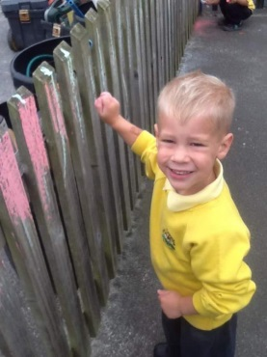

**Wednesday 7th November**

**5:30pm – 6:30pm**



**For an outstanding future, start your child’s learning journey at The Coppice Primary School.**

The Coppice Primary School  
Shawhurst Lane  
Hollywood  
Worcestershire  
B47 5JN

01564 826709

office@coppice.worcs.sch.uk