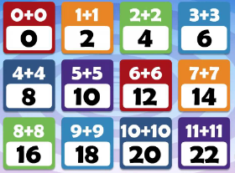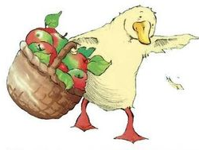

Our Week Ahead

24th February 2020

Published on: 14.2.2020

Our week ahead – What are we going to be learning?

* Listening to the story of ‘*Farmer Duck’.*
* Retell and act out the story using a story map and puppets.
* Writing about Farmer Duck using the correct letter formation, capital letters and full stops.
* Learning what ‘double means’.
* Learning how to record doubles.
* Practicing writing capital letters on the ‘Garden lines’.

Reminders:

* **PE kits** need to be returned after half term. Please ensure that all items still have visible names in each item. If not they will be returned to be named.
* **Reading books and diaries.**

It is important children are reading regularly at home and reading records must be signed to evidence this. We do monitor who is reading on a regular basis at home. More reading books are available at <https://www.oxfordowl.co.uk/for-home/advice-for-parents/reading-at-home/>.

**Early Excellence**.

We have had a lovely half term. Please have a look at your childs online Learning Journal to see what we have been learning about. It would be lovely to hear from you with any comments.

**W.O.W – Word of the Week.**

**Double**

Two of the same thing.

***Dates for the diary:*** **24th/25th/27th February** Reading Workshop- It will be an opportunity to spend time with your child in school and see how we teach reading skills so you can support your child at home using the same strategies. Please remember only 1 adult only per child.

**Friday 28th February** 'Dare to be different' day, Children to bring in 50p for each dare they fulfil. See the poster in the classroom windows.

**Thursday 19th March** – Reception trip to Atwell Farm. Please see the attached letter below for details.

**Friday 20th March** – Science Fair competition, for full details please see the main school newsletter.

**We hope that you all have a lovely half term and we look forward to seeing you after the holiday ☺**