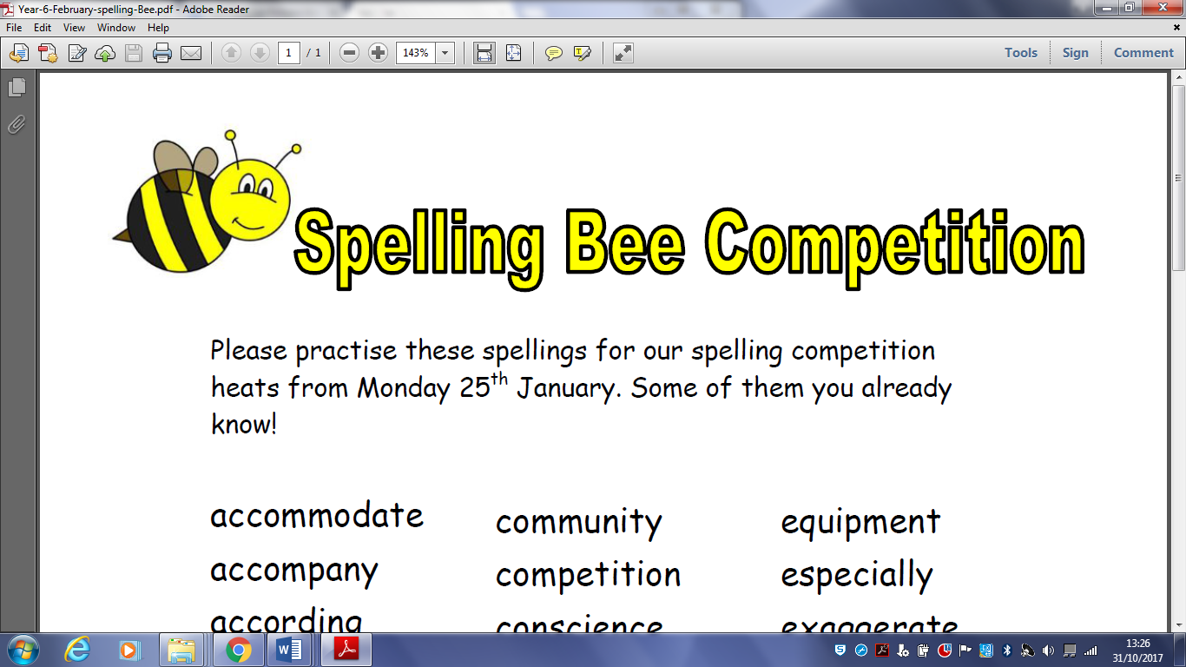 YEAR _5_

Please practise these spellings for our ‘Spelling Bee’ that will take place on …………………………

|  |  |  |  |  |  |  |  |  |  |  |  |  |  |  |  |  |  |  |  |  |  |  |  |  |  |  |  |  |  |  |  |  |  |  |  |  |  |  |  |  |  |  |  |  |  |  |  |  |  |  |
| --- | --- | --- | --- | --- | --- | --- | --- | --- | --- | --- | --- | --- | --- | --- | --- | --- | --- | --- | --- | --- | --- | --- | --- | --- | --- | --- | --- | --- | --- | --- | --- | --- | --- | --- | --- | --- | --- | --- | --- | --- | --- | --- | --- | --- | --- | --- | --- | --- | --- | --- |
| |  |  |  | | --- | --- | --- | | thumb | jostle | familiar | | subtle | credible | rhyme | | limb | visible | system | | doubted | possible | develop | | thumbs | cough | interfere | | glistening | enough | adaptable | | soften | wrestler | understandable | | average | tombs | enjoyable | | reliable | steal | environment | | believable | heard | listener | | predictable | sensible | bustled | | equip | appreciate | castle | | leisure | fasten | hustle | | breakable | visibly | symbol | | aggressive | edible | curiosity | | accommodate | miserable | lamb |   **You will be tested on 20 of these words – but which 20 will they beeeeeee?** |  |  |
|  |  |
|  |  |
|  |  |
|  |  |  |
|  |  |  |
|  |  |  |
|  |  |  |
|  |  |  |
|  |  |  |
|  |  |  |
|  |  |  |