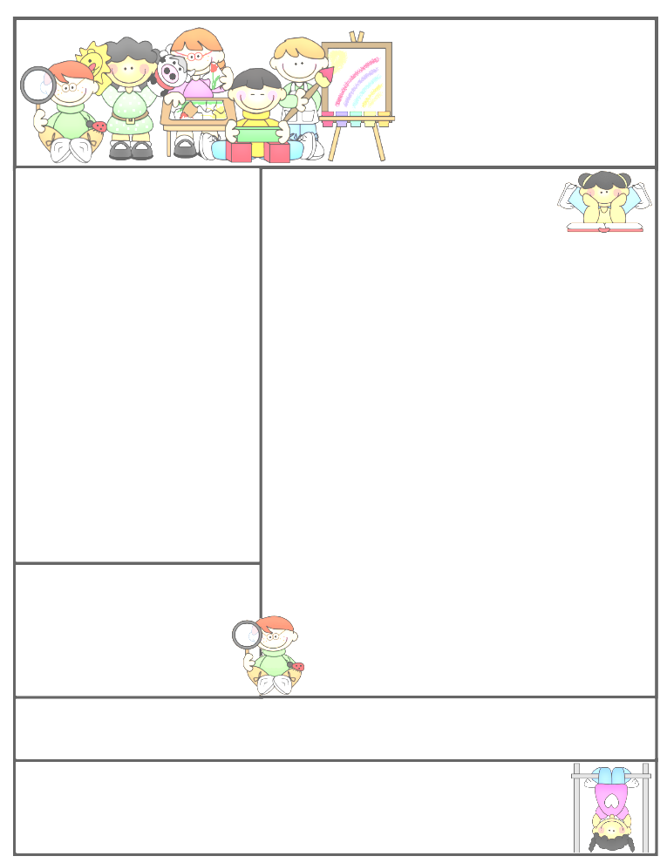

**Important Dates and Messages:**

**Due to current guidelines, sadly we are unable to conduct transition activities as we normally would before the summer holidays. We have created an admissions website containing important information and videos of our staff. If your child is starting in one of our Reception classes in September please visit this website at: https://sites.google.com*/*coppice.worcs.sch.uk/thecoppiceprimaryschooladmissi*/*nursery-admissions**

**We hope you will find this helpful.**

Now that the weather is warmer can you please ensure that your child brings a named sun hat into Nursery each day, we ask that you apply sunscreen before they come into Nursery as staff are not able to do this throughout the day.

Inflatable fun day is next week, NB (Conker class) will be attending on Monday and NTG (Berry class) will be attending on Tuesday. You will need to purchase tickets ASAP via the following link https://www.pta-events.co.uk/coppice/index.cfm?event=event&eventId=37994 If a child does not have a ticket then unfortunately they will not be allowed on the bouncy castles due to health and safety rules as we will require parental consent.

Can you please ensure that children are dressed in sportswear that day with arms and legs covered.

