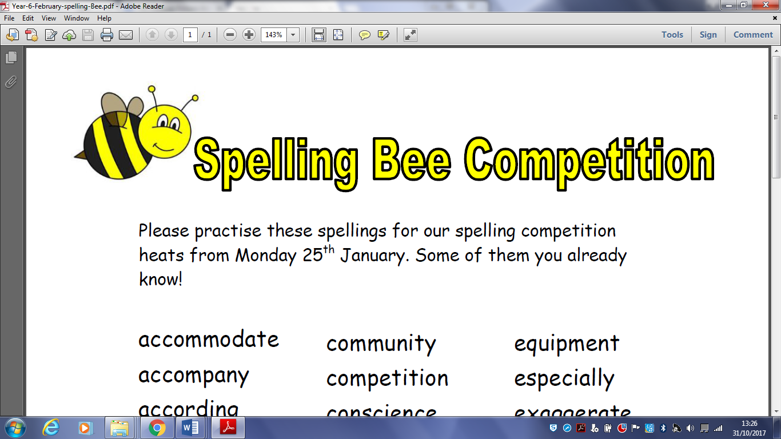YEAR TWO

Please practise these spellings for our ‘Spelling Bee’ that will take place on …………………………

|  |  |  |  |  |  |  |  |  |  |  |  |  |  |  |  |  |  |  |  |  |  |  |  |  |
| --- | --- | --- | --- | --- | --- | --- | --- | --- | --- | --- | --- | --- | --- | --- | --- | --- | --- | --- | --- | --- | --- | --- | --- | --- |
| |  |  | | --- | --- | | parents | friends | | should | weakly | | could | many | | didn’t | I’ll | | I’m | really | | very | with | | past | whole | | half | who | | two | city | | only | walk | | | |  |  |
| **You will be tested on 20 of these words!**  YEAR TWO  Please practise these spellings for our ‘Spelling Bee’ that will take place on ………………………… | | |  |  |
| |  |  | | --- | --- | | parents | friends | | should | weakly | | could | many | | didn’t | I’ll | | I’m | really | | very | with | | past | whole | | half | who | | two | city | | only | walk | | | |  |  |
| **You will be tested on 20 of these words!** | | |  |  |
|  | | |  |  |
|  |  |
|  |  |
|  |  |