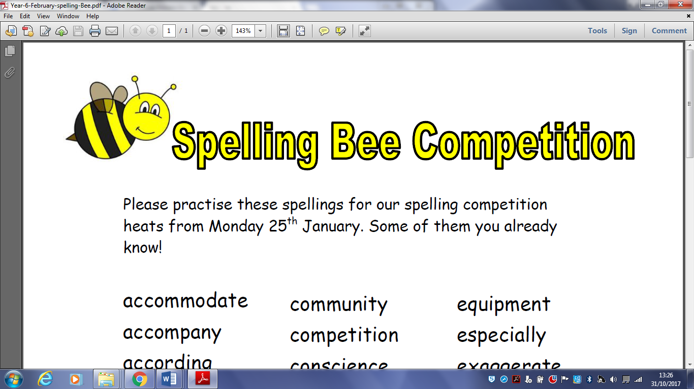

YEAR 2

Please practise these spellings for our spelling Bee that will take place on Wednesday 28th March. **You will be tested on 20 of these words – but which 20 will they beeeeeee?**

|  |  |  |
| --- | --- | --- |
| kindness | flies | saddest |
| tries | replies | fatter |
| happier | copies | fattest |
| crying | babies | runner |
| darkest | carries | runny |
| running | copied | enjoyment |
| nicer | copier | playful |
| shiny | happiest | plainness |
| dropped | cried | badly |
| amazement | replied | happiness |
| wildest | copying |  |
| catches | replying |  |
| beautiful | hiking |  |
| sadness | hiker |  |
| careful | patting |  |
| hopeless | patted |  |
| happily | humming |  |
| walked | hummed |  |
| lovely | dropping |  |
| cleverest | sadder |  |
|  |  |  |
|  |  |  |
|  |  |  |
|  |  |  |
|  |  |  |
|  |  |  |
|  |  |  |
|  |  |  |
|  |  |  |
|  |  |  |
|  |  |  |
|  |  |  |