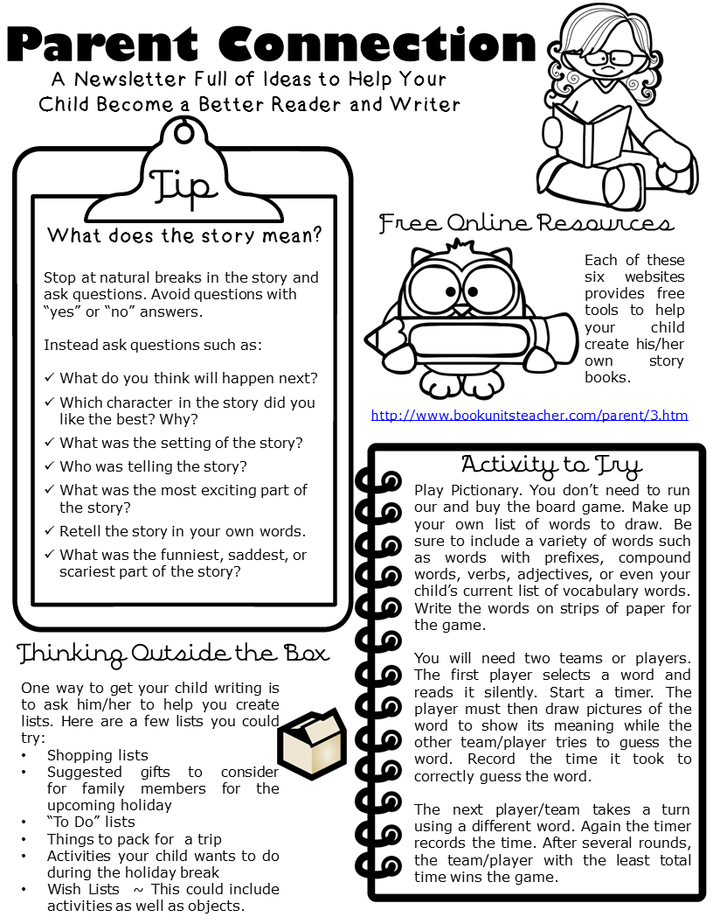

This week we have been reading Supertato. We then found, and wrote, our very own secret messages. The children have been exploring the classroom looking for these messages, telling us what superpowers it has given them and then having a go at writing their very own. It would be great if you could practise writing at home. Below are some activities for you to try

* Go with your child’s interest. If they love superheroes, maybe they could draw a picture of the Hulk and then write his name. Or make up their very own superhero, name them and write what powers they could have
* When going shopping with your child, encourage them to write what things they would like to buy too
* Don’t be afraid to get messy! Writing with paint, in the mud, sand etc can help your child have fun and practice their writing at the same time
* **PLEASE NAME ALL ITEMS OF CLOTHING!**
* Please send in your family photograph with a frame so the children can talk about the people that are special to them.
* Mrs Flynn has started her speech, language and communication lead role and works across Reception and Nursery. Mrs Walters is the teacher with Mrs Wicking in her absence.
* If your child is self-isolating or shielding, then you will be able to access some activities to work on at home. Please go to our school website and click on the blue pop up box. This will take you to our home learning site.

**Important Messages:**

* Due to the change in weather, could you please send your child to school with a coat so they can comfortably play outside
* A reminder that a donation of £5 ,per term, used for craft resources is to be given to your child’s class teacher
* For PE can we ask that your child wears toned down, non-branded trainers please and not pumps
* If your child would like milk and you have not yet signed up, please do so at www.coolmilk.com. It is free for all children under five
* **http://www.canigoandplaynow.com/play-school-tv---the-message-centre.html**

**25th September 2020**

**Reception Newsletter**