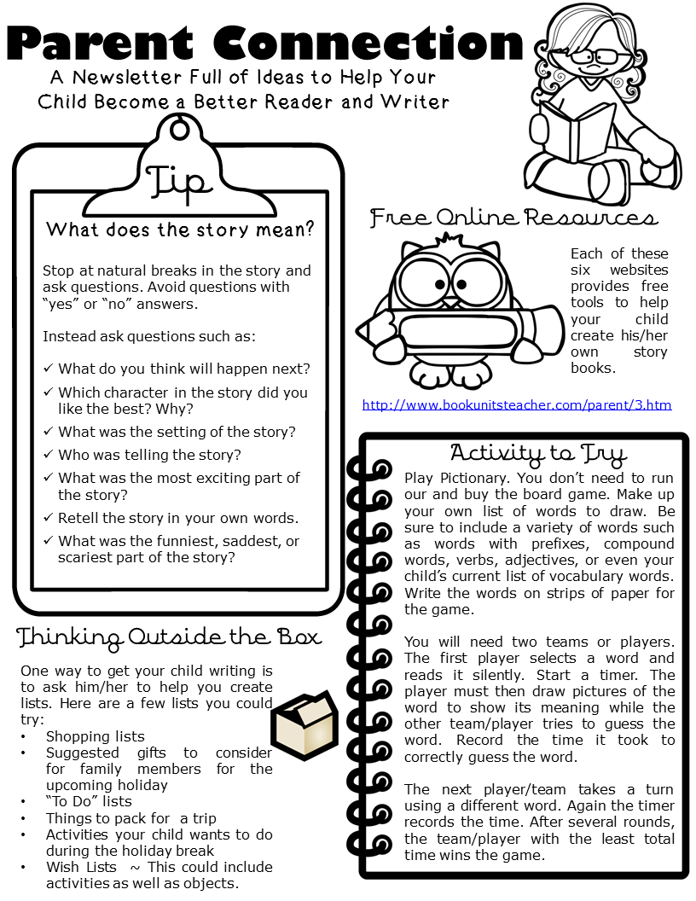

**16th November 2020**

Revisit phonics lessons on Bug Club to consolidate the sounds we have learnt.

Last week we were learning about one more. At home, face down number cards to 10. Roll a die and take it in turns to see if you can turn over the card that is one more. When you pick the correct one, you keep the card. The winner is whoever has the most cards

**Important Messages:**

This week, we are having a special focus on the celebration called Diwali.

Make sure to book an appointment with your child’s key worker for parents evening.

Due to allergies, can we ask that your child brings only fruit as a snack.

Thank you for all the craft money that has been donated. With the money, we have been able to buy new items to enhance your child’s learning