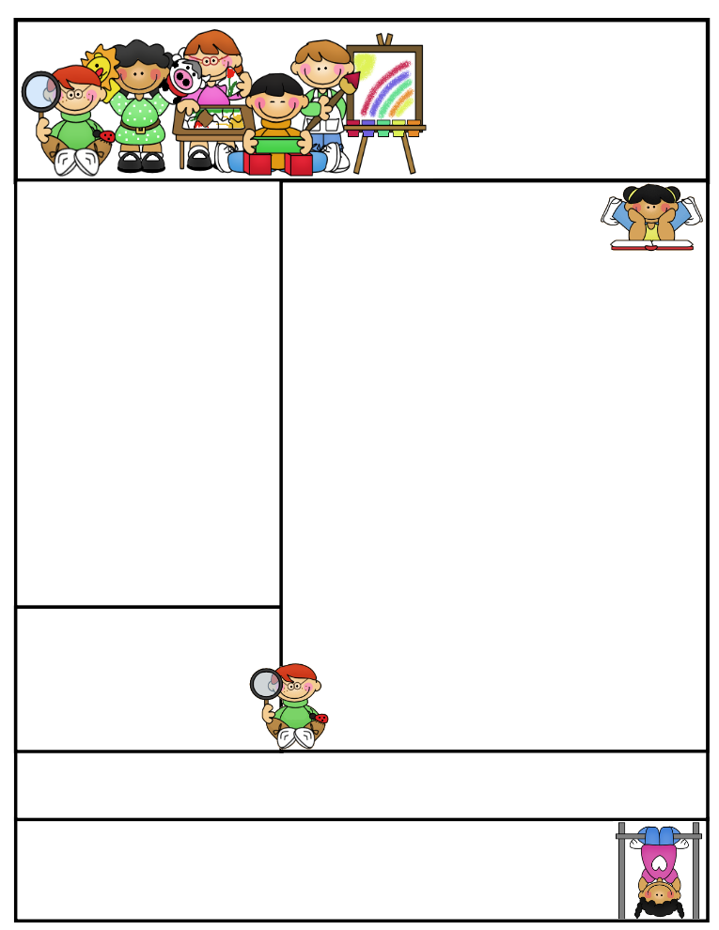..

**Nursery  
Newsletter**

18th October 2019

**This week we have been…**

* … washing babies and washing cars!
* … making flapjacks.
* … learning about ‘who’ and ‘under’.

**Important Dates and Messages:**

* **Next week we will be making and eating coloured toast in school.** Ingredients will be sliced white bread, milk and food colours. **Please advise us of any intolerances/allergies your child may have.**
* **The next drop in sessions held by Worcestershire Speech and Language therapists** will be at The Scott Atkinson Centre, Woodrow, Redditch B98 7HU on Friday 25th October, 2.30-3.00pm and at Catshill Clinic, Catshill, Bromsgrove B61 0NJ, on Tuesday 12th November, 9.30-10.00am. Please drop in if you have any concerns about your child’s speech and language.
* **Please** **remember - we have children in Nursery with severe allergies** – no foods containing nuts or sesame in lunch boxes. Thank you.
* **We encourage our children to be independent**. Please help us by teaching your child to put on his/her coat independently. We will obviously lend a helping hand if needed!
* **From half term, starting on Thursday 7th November**, we will be going to Forest Rangers every Thursday morning. Children can wear their own suitable, weather appropriate clothes - arms and legs covered and **wellies are essential. Also, we need to keep wellies** in Nursery as we are playing out in all weathers. Don’t forget to write your child’s name in them!
* **We would still like** donations of compost for use in Nursery – any quantity is acceptable!
* **Should you go on a nature walk at the weekend**, please bring in any natural objects such as acorns, conkers, feathers etc to be used in class.
* **After half term** we will be inviting you to parent workshops to help you learn more about physical development, reading and communication and language. Please look out for dates coming soon!

**Happy Birthday to:**