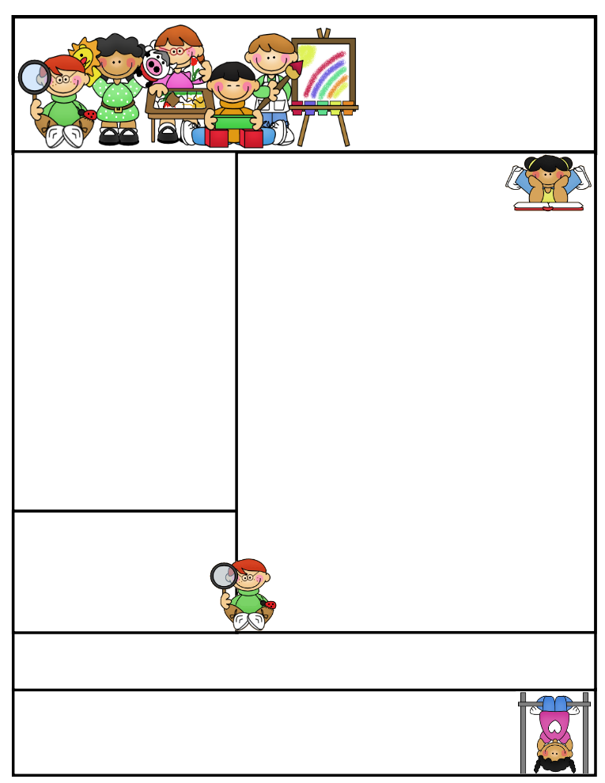

**Nursery  
Newsletter**

20th September 2019

**This week we have been…**

* … practising our listening and waiting skills, playing the ‘bubble game’.
* … to the Infant Hall for P.E. and to the adventure playground.
* …exploring the classroom areas .

**Important Dates and Messages:**

* **If you have any concerns about your child’s speech,** please feel free to drop in at the Worcestershire Speech and Language ‘Walk and Talk’ session on **Friday 27th September**, 2.30 – 3.00pm at the Scott Atkinson Centre, Woodrow, **Redditch B98 7HU.**
* **On Friday 27th September** we will be holding a coffee and cake fundraiser for Macmillan Cancer Support. Please join us from 3.00pm in the Junior Hall. (We will endeavor to be ready for as close to 3.00 pm as possible!) We will be asking for £5 per family – more details to follow on Monday.
* **We ask for a £5 cooking/craft donation every half term**. Please send donations in a sealed, named envelope and hand to Nursey staff. Thank you to those who have already sent in contributions, as you will be aware from media coverage, school budgets are very stretched at this time.
* **Please remember: -** If you are providing packed lunches, please do not include **anything** containing **sesame seeds** or **nuts** of any kind. **We have children in Nursery with severe allergies**. Thank you.
* **We will be uploading photos** ontothe School website. Please take a look and see what we’ve been up to! (We can only publish photographs of those children for whom we have permission.)
* **Our first Parent Consultation Evening** of the year will take place on Monday 18th November.
* **Please remember** to fill in the **free milk form** should your child require milk during their time in Nursery.
* **Please be aware** that there is **no parking on site** for parents at school times. (Blue badge holders please speak to Mrs Marks in the office.

* **Please sign up** for the whole school newsletter as there will no longer be a paper version sent out each week.