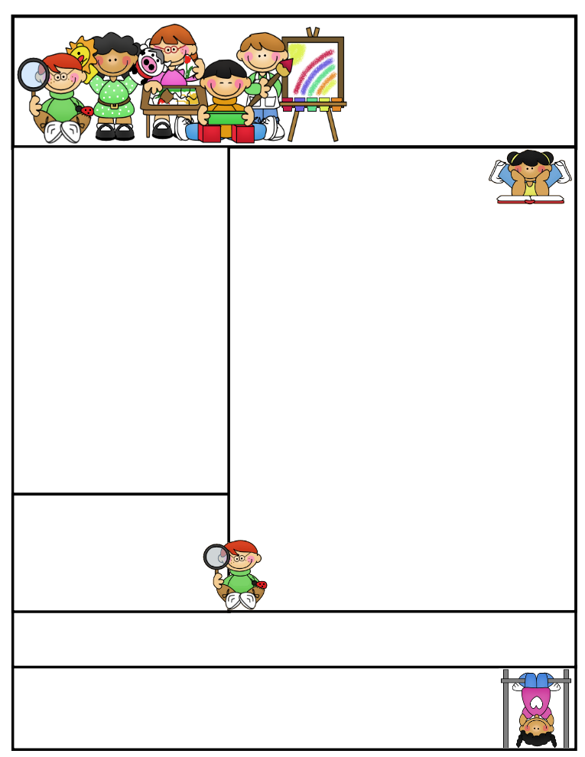..

**Nursery  
Newsletter**

8th November 2019

**This week we have been…**

* … learning about ‘where’.
* … making a chocolate firework biscuit.
* … working in the playdough chip shop.

Focus Child ystem’

**Important Dates and Messages:**

**Parent Consultations - Monday 18th November**

* **Sign-up appointment sheets** will be available from Monday 11th November. They will be in the (junior) hall from 7.00 am and then back in the classrooms when Nursery starts.

**PLEASE SIGN UP WITH YOUR CHILD’S KEY WORKER** (ask a member of staff if you can’t remember the key worker!)

* **Please look in your child’s book bag this week**, as you will find your login details and password for your child’s Learning Journey. Please log on to see photos of your child. Each half term, all children will get pages added to their Learning Journey.
* **From next Monday we will be starting the ‘Focus Child’ system.** At some point, your child will be a focus child. This means that their key worker will make ’spotlight’ observations of them during the week. Prior to this, we will send home a sheet informing you that it is your child’s turn, asking you to tell us about any significant happenings in your child’s life at this time.
* **We would like to invite you to our first Parent Workshop on Wednesday 27th November.** We will talk about physical development and tell you about gross and fine motor activities designed to help your child on the road to writing. There will be two opportunities to attend – the first session will be held in the Phiz Lab from 2.30 – 3.00 pm (places will be limited due to space) **or** you may prefer to attend the later session, which will be held in the Infant Hall from 5.00-6.00 pm.
* **Individual school photos will be on Tuesday 12th November and sibling photos (Coppice children only) will be on Monday 18th November.** If you have a child in **NHT Afternoon Nursery** and want them to have a photograph taken with their older Coppice siblings, please take all your children (including the older ones) to the infant hall for 9.00am. You will then need to take your older child(ren) round to the office so that they can be marked present (they will not receive a late mark) before they go to class**.**
* **Next week** we will be learning all about toys and materials.

.

**Happy Birthday to:**