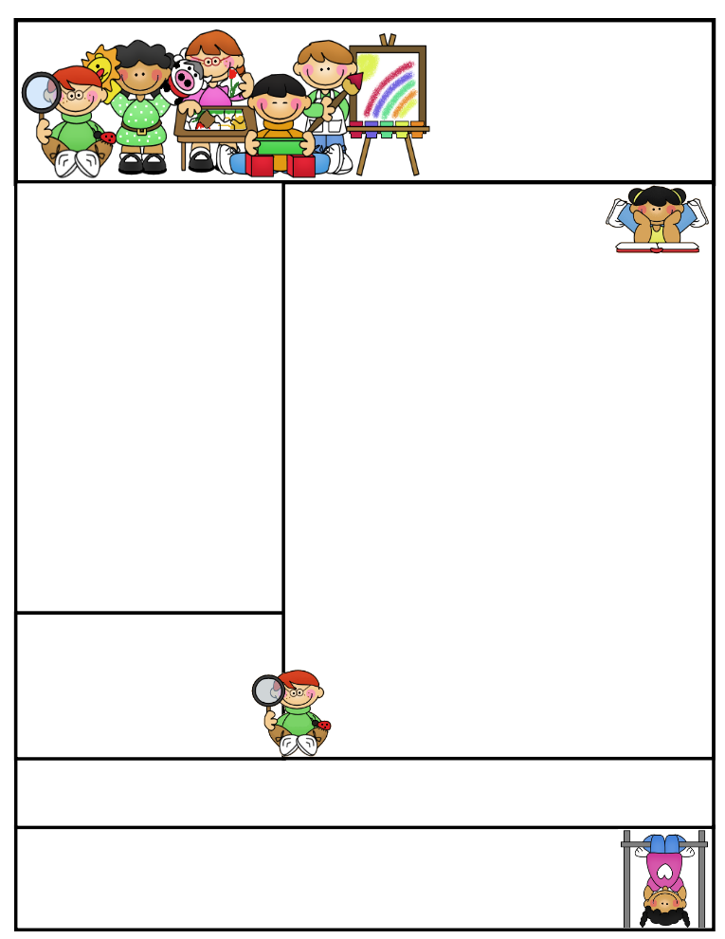am..

**Nursery  
Newsletter**

Published on 28/02/2020. W/c 01/03/2020

**This week we have been…**

* … practising our counting.
* … making pancakes topped with lemon juice and sugar.
* … helping Concept Cat to learn about ‘quiet’ and ‘not quiet’.

Focus Child ystem’

**Important Dates and Messages:**

**Nursery Parent Consultations will take place on Monday 23rd March.**

* **Advance Information –** At the end of next half term, we will be holding an **Easter Bonnet** **Parade**, so start getting you craft materials together, ready to create an amazing hat!
* **Forest Rangers will be starting again next week,** so please make sure that your child is dressed appropriately.
* **We do not require any more junk at present.** Thank you for all your contributions, we are sure you all enjoy receiving the wonderful models your children create!
* **Mr Mace** will be visiting us next week to tell us all about the work he does around school.
* **Kitty and Polly will be teaching us about ‘oblongs’ next week.** We use the term ‘oblong’ instead of ‘rectangle’ because in geometry, a rectangle is a quadrilateral (four sided figure) with four right angles, so, a square is also a rectangle.
* **Please be sure** **to inform** **office staff** if your child is going to be absent from Nursery for any reason.
* **Please note: £5 cookery/craft money is due for this half term, thank you.**

.

**Happy Birthday to: Wahenoor.**