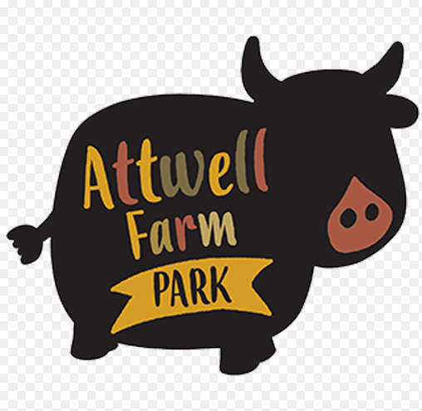
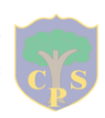

Friday 14th February 2020

Dear parents,

As part of our animals topic we will be taking the Reception children to Attwell Farm Park on Thursday 19th March.

This trip will bring together all the learning the children will have experienced next half term on farm animals, pets and animals and their babies.

We will be leaving school at 9.30am and returning before the end of the school day. The children will need to wear their school uniform and be dressed appropriately for the weather as some of the time will be spent outside or in barns. Your son/daughter will need a water bottle, a packed lunch, including a drink, in a named disposable bag please. If you would like school to provide a packed lunch for your son/daughter please inform a member of staff and we can book them in. We need to know by Friday 13th March if you would like the school to provide a lunch.

In accordance with our Charging Policy we are asking for a voluntary contribution of £13, per pupil, to cover costs such as travel, entrance fees and insurance. Unfortunately, in some cases where there are insufficient contributions, we have to consider cancelling trips or events which we naturally try to avoid. Your contributions go a long way to helping us manage our school funds to ensure maximum value for every child, so thank you in anticipation of your ongoing financial support.

If you would like your son/ daughter to take part in this educational visit could you please give consent (by the payment) and make a payment on ParentPay by Friday 13th March. If you are unable to pay via Parent Pay, please visit the School Office for a consent form. Anyone who has not given consent by this deadline will be unable to attend the trip.

If you have any further questions please do not hesitate to speak to one of the teaching staff in Reception
Yours sincerely,

Mrs Tomkinson, Miss Dixon and Miss Gough

