Jacqui Phillips
Road Safety Team Leader,
People Directorate,
Countryside Centre,
Wildwood Drive,
Worcester.
WR5 2LG

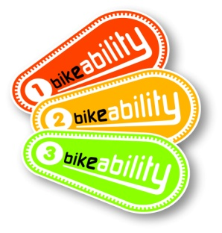
Dear Parent/Carer,

Level 2 Bikeability Course

I write to give you details of the above course and to ask you to return the enclosed Application/Parent Consent Form if you wish your child to take part. Please read the enclosed form carefully before signing and returning promptly to the school.

Bikeability is the new cycle training for the 21st century, designed to give the next generation of children the skills and confidence to ride their bikes on today’s roads. To get their Bikeability award, children will be instructed on how to ride their bikes to the Government-approved National Standard for Cycle Training. More information for parents and participants, including additional resources, advice and offers is available on the https://bikeability.org.uk/participants-hub/

Your child must be able to ride their bike to participate. This training is about developing children’s riding skills and confidence in moderate traffic situations on single lane roads and simple junctions. (If you are unsure whether this training is appropriate for your child please contact us at Bikeability@worcestershire.gov.uk).

Both Level 1 and 2 Bikeability are incorporated in a Level 2 course:

- The Level 1 course helps children get more skills and confidence in riding their bikes in the playground and gets them ready for cycling on the road. They MUST already be able to ride a bike – pedal and freewheel, raise a hand from the handlebar, change direction and stop with control – to participate in this level. Following the playground session our instructors may conclude that some children are not yet ready to be exposed to traffic situations. In this situation they will not be allowed to continue with the training on the road. This will be entirely at the instructor’s discretion following a risk-based assessment of the child’s riding capability. The safety of the individual child and the wider group will be paramount in reaching this decision.

- Level 2 training is undertaken on quiet local roads but with real traffic conditions. By completing Level 2 your child should gain the necessary knowledge and understanding as well as be able to demonstrate the skills needed to cycle on quiet local roads. Continuing practice and encouragement will further develop the child's confidence and cycling competency level. Children will be encouraged and inspired to achieve the levels, recognising that there is always more to learn and to enjoy on a bike.

Checklist for training
You and your child need to ensure that they are adequately prepared for their training. You must ensure that your child’s bike is roadworthy; the enclosed bicycle checklist will help you. Our instructors may refuse to take out any child whose cycle is considered un-roadworthy or not the correct size.

The first step to safer cycling is to ensure that bikes are regularly checked and children doing Level 1 and 2 Bikeability will be shown what to look out for and simple maintenance checks. Covid-19 precaution measures and social distancing mean we will be seeking to minimise our contact with your child’s bike and helmet. It is essential that your child’s bike is in good working order and that your child knows how to fit and adjust their own helmet.

When checking your child’s bike prior to training, please ensure:
- Saddle and handlebars are adjusted to the correct height.
- Front and rear brakes are functioning correctly.
- Tyres are pumped up with no punctures.
It is also important that your child is dressed appropriately for the training:
- It is a requirement that your child wears a properly fitted, undamaged and approved cycle helmet throughout the training.
- Think about the weather – if rain is forecast please ensure that your child has waterproof clothing with them. In high heat/UV please ensure they are protected.
- Ensure your child is wearing suitable shoes or trainers (not sandals.)
- High-visibility vests will be provided for each child on the day.

Once your child has completed the Bikeability course, they will receive a badge, booklet and certificate. If you require any further information please contact us at Bikeability@worcestershire.gov.uk. We would also welcome your feedback after completion of the training.

Yours sincerely,
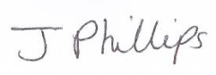
Jacqui Phillips
Road Safety Team Leader (Bikeability)

