** Please check your child's bike before they attend training **

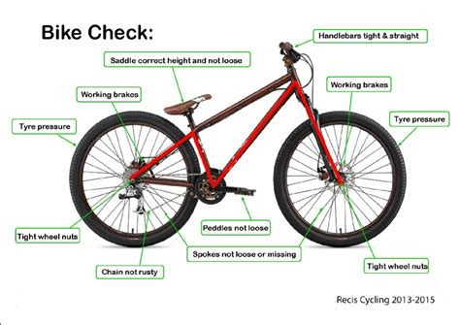

1 & 2: Brakes and Cables
- Do they work?
- Check blocks are in the right place
- Blocks should not be touching the tyre
- Blocks should not be badly worn out
- Cables should not be frayed or broken
3: Tyres
- Make sure they are pumped up
- Not worn or damaged
4 & 5: Wheels and Spokes
- Should not be damaged
- Should not be buckled or loose
6: Lights (if fitted)
- Clean and working
- Not loose or incorrectly positioned
7: Reflectors (if fitted)
- Should not be broken or dirty
8 & 9: Steering and Handlebars
- Should not be loose
- Should have good grips and end plugs
- Should not be too high or too low

For further information and video go to: www.bikeability.org.uk/bikeability-training/get-ready/

10: Bell (if fitted)
- Does it work?

11: Frame and Forks
- Not rusted, damaged or bent

12: Pedals
- Must spin freely
- Not be damaged or broken
13: Saddle
- Adjusted for height
- Tightened
14 & 15: Chain & Gears
- Not too loose or too tight
- Lubricated and not rusty
16: Mudguards (if fitted)
- Make sure do not catch moving parts
- Make sure not loose
General:
- Bike should not be too big or too small
Helmet:
- Should be British Standard approved
- Should fit correctly

